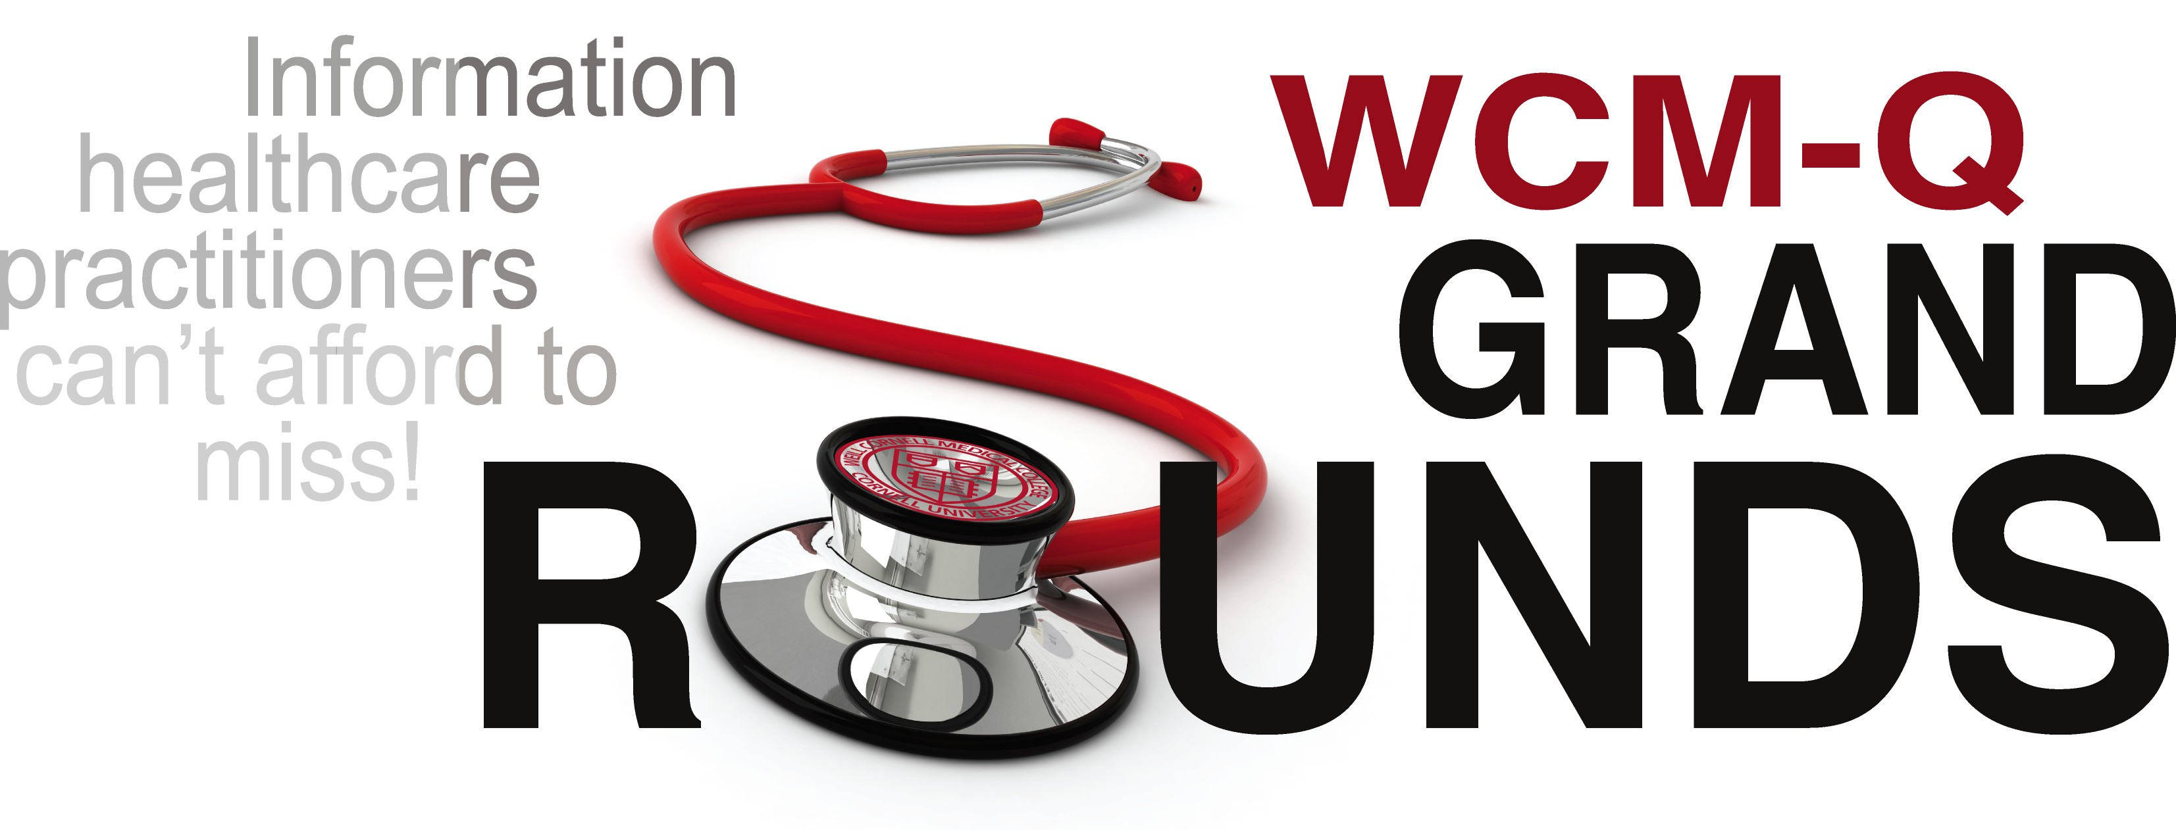

**Diabetes, the Ticking Time Bomb**



**Prof. Alexandra Butler**

**Adjunct Professor of Medicine/Endocrinology**

**Diabetes Research Center**

**Qatar Biomedical Research Institute**

**Sunday, December 9 2018 3:30 PM – 4:30 PM Lecture Hall 2**

## Target Audience:

Physicians, pharmacists, nurses, dentists, and allied health professionals

## Course Objectives:

At the end of the session, participants will be able to:

1. Recognize the similarities and differences between Type 1 and Type 2 Diabetes
2. Discuss the current therapeutic limitations
3. Describe the new technology that will be instituted in the future

**Accreditation and Credit Designation Statements:**

**QCHP Accreditation Statement:**

Weill Cornell Medicine-Qatar is accredited as a provider of Continuing Medical Education (CME) and Continuing Professional Development (CPD) by the Qatar Council for Healthcare Practitioners (QCHP) of the Ministry of Public Health.

This activity is an Accredited Group Learning Activity (Category 1) as defined by the Qatar Council for Healthcare Practitioners-Accreditation Department and is approved for a maximum of 1 hour.

**ACCME Accreditation Statement:**

The Weill Cornell Medicine-Qatar is accredited by the Accreditation Council for Continuing Medical Education (ACCME) to provide continuing medical education for physicians.

The Weill Cornell Medicine-Qatar designates this live activity for a maximum of 1 *AMA PRA Category 1 Credit™*. Physicians should claim only the credit commensurate with the extent of their participation in the activity.

**Faculty Disclosure**: It is the policy of Weill Cornell Medicine-Qatar to adhere to Qatar Council for Healthcare Practitioners (QCHP) and Accreditation Council for Continuing Medical Education (ACCME) Criteria, Policies, and Standards for Commercial Support and content validation in order to ensure fair balance, independence, objectivity, and scientific rigor in all its sponsored programs. All faculty participating in sponsored programs are expected to disclose relevant financial relationships pertaining to their contribution to the activity, and any discussions of off-label or investigational uses of approved commercial products or devices, or of any products or devices not yet approved in the United States and elsewhere. WCM-Q CME/CPD activities are intended to be evidence-based and free of commercial bias.

**Speaker:** Alexandra Butler, MD, has *nothing to disclose and WILL NOT BE DISCUSSING any unlabeled/unapproved use of drugs or products.*

*Course Director/Planning Committee:* Thurayya Arayssi, MD; *Planning Committee:* Aicha Hind Rifai, MD; Sohaila Cheema, MBBS; Sheila Qureshi, PhD; Therese Lanigan, MSc; Maria Paiva, BSP; Deema Al-Sheikhly, MRes, MEHP; Christopher R. Triggle, PhD; Dominique Laatz; MSc; Mary Parrott, RRN, MA – *have nothing to disclose*

*Course Director/Planning Committee:* Stephen L. Atkin, MBBS, *has disclosed the following:* Educational Lectures with Novo Nordisk

*ICR:* Thurayya Arayssi, MD, *has nothing to disclose*

*Coordinator:*Laudy Mattar, MMI, *has nothing to disclose*

*CPD Staff*: Thurayya Arayssi, MD; Deema Al-Sheikhly, MRes, MEHP; Laudy Mattar, MMI; Ameena Abdul Rahim – *have nothing to disclose;*

*CPD Satff: Safia Rabia has disclosed the following: Spouse, employee of Al Wehda Medical Group*

*ICR:* Thurayya Arayssi, MD, *has nothing to disclose*

*WCM-Q does not accept industry support for any regularly scheduled series. Any exceptions to this are approved by the CPD Oversight Committee and will be disclosed prior to this presentation.*

## To be eligible to receive a certificate:

1. Sign-in at the beginning of each session.
2. Complete the evaluation.

