Jason Howard | 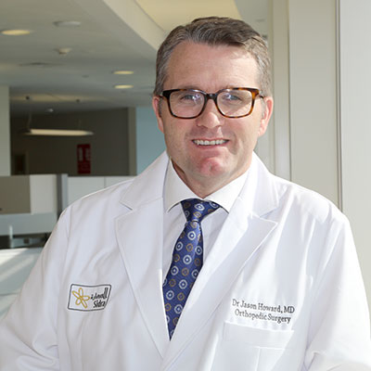
Qualifications  B.Eng, MD, FRCSC  Job Title  Division Chief of Orthopedic Surgery  Division  Surgery  Specialties  Orthopedic Surgery, Pediatric orthopedic and spine surgeon  Years of Experience  14  Languages Spoken  English | Short Biography  Prior to joining Sidra as Chief of Orthopedic Surgery, Dr. Howard was a full-time Assistant Professor of Surgery in the Faculty of Medicine, University of Calgary (Calgary, Canada) and a practicing pediatric orthopedic surgeon at the Alberta Children’s Hospital from 2005 to 2008. During his time at the Alberta Children’s Hospital, Dr. Howard was also the Clinical Director of the C.H. Riddell Family Movement Assessment Centre (Clinical Gait Laboratory). He subsequently was appointed as Assistant Professor in the Faculty of Medicine at Dalhousie University (Halifax, Canada) and was a practicing pediatric orthopedic surgeon at the IWK Health Centre from 2009 to early 2014. In February 2014, he accepted a new post in Qatar helping to develop the Orthopedic and Rehabilitation programs for Sidra.  Dr. Howard completed his medical training in Canada at Memorial University in 1998 and subsequently completed his residency in Orthopedic Surgery at the University of Calgary in 2003. Dr. Howard then moved to Australia to pursue sub-specialty Fellowship training in Pediatric Orthopedic Surgery at the Royal Children's Hospital, Melbourne. This was followed with a Fellowship in Pediatric Spine Surgery at Starship Children's Hospital in Auckland, New Zealand. In late 2004, Dr. Howard was the International Traveling Fellow for the Japanese Pediatric Orthopedic Association, based in Yokohama, Japan. He became a member of the Royal College of Physicians and Surgeons of Canada in 2003. Dr. Howard also recently completed a sabbatical at Inselspital, Bern, Switzerland where he completed a fellowship focusing on pediatric hip preservation surgery.  His clinical areas of interest include neuromuscular disorders (cerebral palsy, spina bifida, muscular dystrophies), pediatric hip, pediatric spine, and foot deformities. In addition to his medical training, Dr. Howard also has a Bachelor Degree in Electrical Engineering and graduate studies in Biodesign at Stanford University, focusing on the development of new medical technologies.  Dr. Howard is active in research and knowledge transfer in pediatric orthopedics. His main areas of research interest involve the development of robotic-assisted minimally invasive techniques for scoliosis surgery and basic science/clinical studies involving children with cerebral palsy. He is also co-editor of an upcoming textbook: The Pediatric and Adolescent Hip: Essentials and Evidence (Springer, London; with co-editors, Sattar Alshyrda, James Huntley, and Jonathan Schoenecker) due to be released in early 2019.  Dr. Howard continues to be active in medical student and resident teaching through Weill Cornell Medicine and Hamad Medical Corporation, respectively.

