–––––––––––––––––––––––––––––––––––––––––––––––––––––––––––––––––––––––––––––––

BIOGRAPHY

Ali Ait Hssain, MD, DESAR, MSc

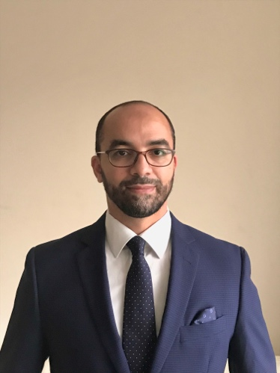

Consultant Intensivist

Member of the ECMO Team

Hamad General Hospital

Senior consultant intensivist and member of the ECMO Team in Hamad General Hospital, in Doha, Qatar, since 2014.
He received his medical degree and completed his residency of anesthesiology and critical care medicine from the University of Limoges in France. He obtained a Master of Science in Human Nutrition in 2007 from the University of Clermont Ferrand, France.
In 2006, he served as assistant clinical professor in University d’Auvergne in Clermont Ferrand, France and worked for 9 years as consultant intensivist in medical ICU in Gabriel Montpied university Hospital, France. He was at the origin for the launch of the ECMO program in his center in 2007. He has initiated and led a post ICU clinic in 2009.
His specific ICU interests include Sepsis, nutrition, ECMO, medical simulation and innovation. He is the lead for the ECMO Simulation Team Of Doha (ECSiTeD) and at the origin of a new ECMO mannequin designed with his team for ECMO cannulation training that has been used in several countries. He is involved in the design of several multicenter trials as investigator in international and multicenter collaborative projects such as Weill Cornell Medicine College. He is author of more than 30 papers and book chapters. He is the actual the lead for research in the medical intensive care unit in Qatar and the lead PI for three research on COVID-19 patients.
He is associate editor of Journal of transversal medicine for the critical care section.

